

INFORMATION TECHNOLOGY PROGRAMME

COMP902 Advanced Information Technology Specialised Project
Progress Report

Student Name | Viacheslav Vorozhbit
Student ID | 20230119
Project Title
Supervisor | Dr. Saranya Selvarangan
Report# | 1
Date | 10 July 2026

Contents

1. Progress 3
Problems Encountered 6
3. How Problems were Dealt With 6
4. Plan for Next Reporting Period 6
References 7

Progress
During this period, I was able to become familiar with the methods and technologies that are currently used and can be used to automate the workplace of a construction company manager.
Some systems are multifunctional and designed for large corporations. They are typically very comprehensive and can be customized for any task but typically require a well-trained specialist to operate. These systems offer many advantages, including stable operation and vendor support. However, they are also very expensive, require extensive customization, have a complex interface, and are generally unsuitable for small construction companies. The most famous of them
- SAP S/4HANA (ERP)
- Oracle Primavera P6
- Microsoft Project
- Procore
- Autodesk Construction Cloud
- Oracle Aconex
Typically, small and medium-sized construction organizations with one or two managers typically use a set of different tools, Excel spreadsheets, Outlook Mail, shared drives in the cloud (OneDrive or Google Drive)
Likewise, processing incoming correspondence, receiving invoices, collecting information on suppliers and prices, distributing quotas, and notifying clients and contractors falls on the shoulders of the manager and therefore must be well organized and automated.
Along with corporate systems, there are many free and inexpensive tools for automating processes in small and private businesses, such as
- Microsoft Power Automate
- n8n
- Zapier
- Make
Routine operations such as checking websites, emails, receiving invoices and notifications, uploading documents, and organizing files take a lot of time every day and are very tiring for a manager.
The obtained data should be organized, saved in a convenient format and preferably centralized so that they are easily accessible to the manager and searchable and convenient for tracking the status of processes.
Therefore, a combination of Power Automate and Notion was chosen for the research project.
Power Automate is a convenient low-code tool that allows you to automate routine processes quickly and flexibly without much expense and with the ability to quickly adapt to changes.
A gap was identified: current research on AI applications in this area focuses primarily on project planning, risk forecasting, and business analytics, with little attention paid to automating routine, daily workflow management tasks using AI. This is particularly relevant for small businesses, where everything falls on the shoulders of a single manager—document processing, vendor interaction, task creation, and workflow coordination. Furthermore, the use of AI to manage low-code tools in the development of practical workflow management solutions remains understudied.
Power Automate comes in two versions: Desktop and Cloud. At this stage, Desktop is used because the user prefers to store data locally.
At this stage, several Power Automate processes have been created. They perform tasks such as processing incoming mail, analyzing text and headers, and storing attachments in dynamically structured folders.
For this purpose, special folders are organized in MS Outlook and filters are added to the mail, and all incoming notifications will be sent to folders in accordance with the rules.
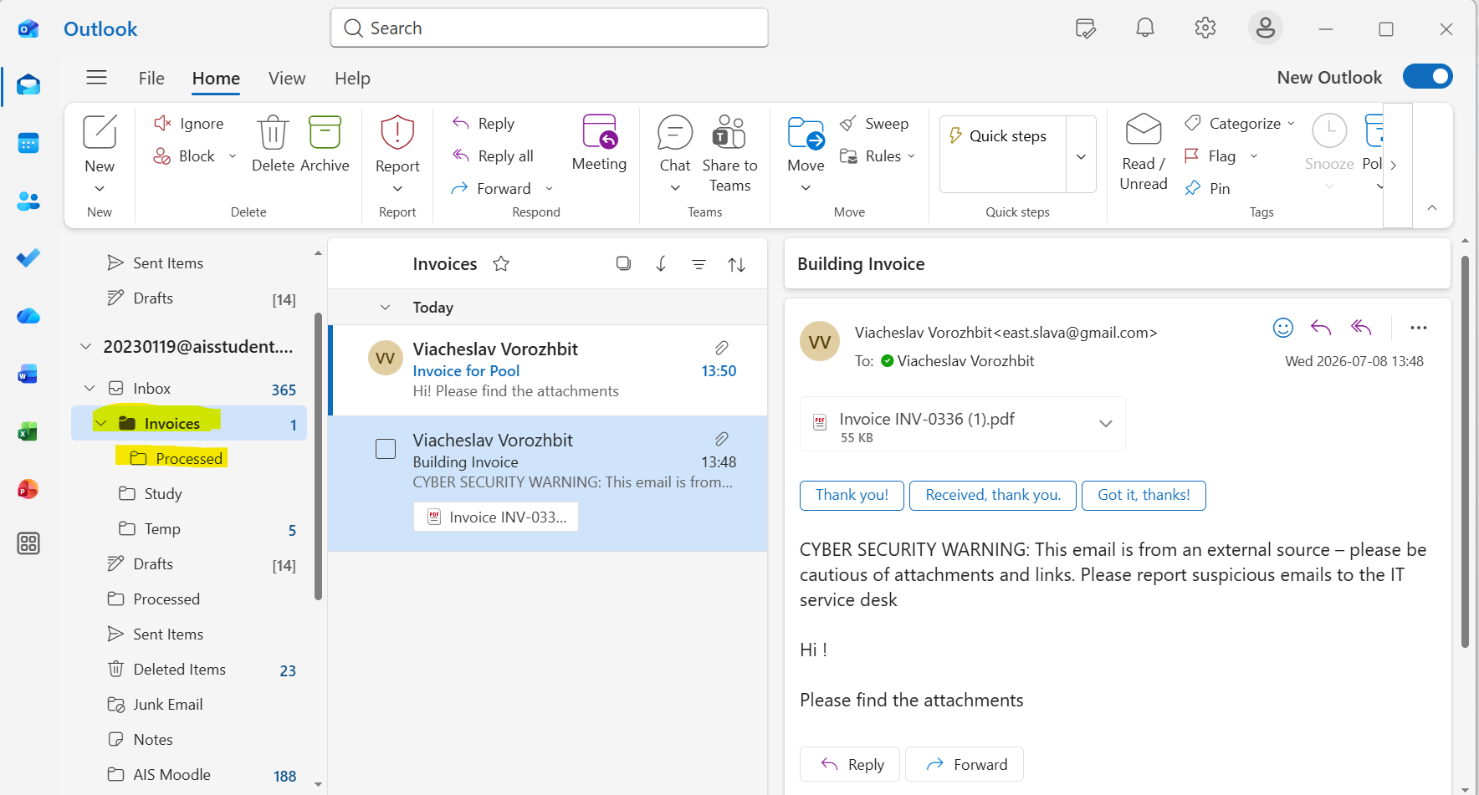
In Power Automatic, a process is created—a logical sequence of actions—that will check messages received in a special folder, process them, and save attachments according to the required logic. After processing, messages should be moved to the Processed folder so the manager can clearly see how many messages have been processed and which, if any, have not been processed.
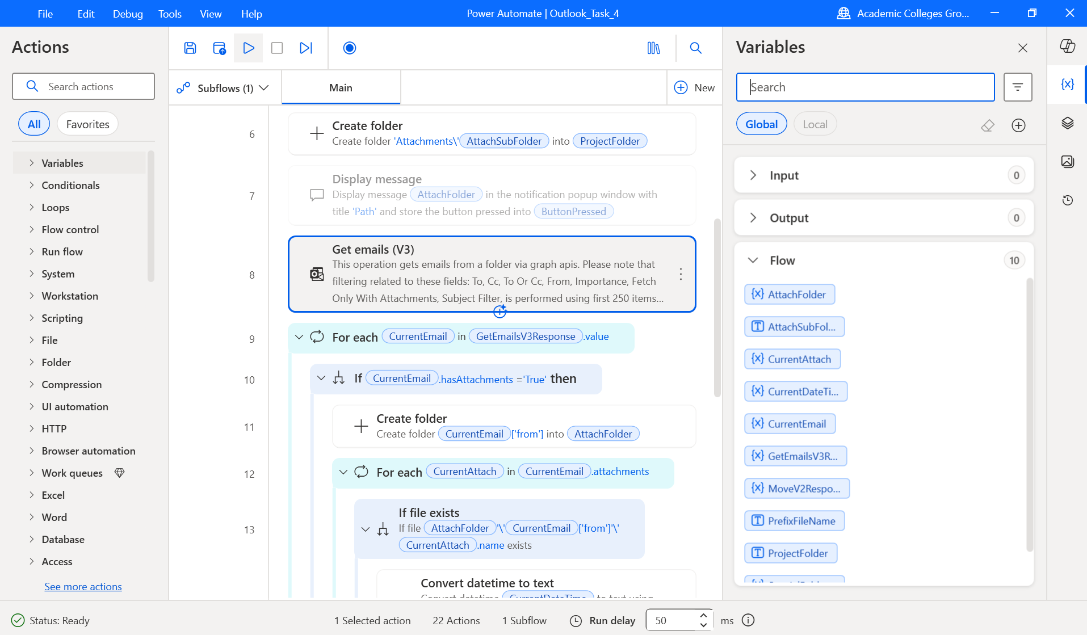
Another part of the processes scrapes the website and saves the table data to disk and transfers certain values to the resulting file for further analysis of accounts, obtaining aggregate values, calculating taxes and forecasting expenses.
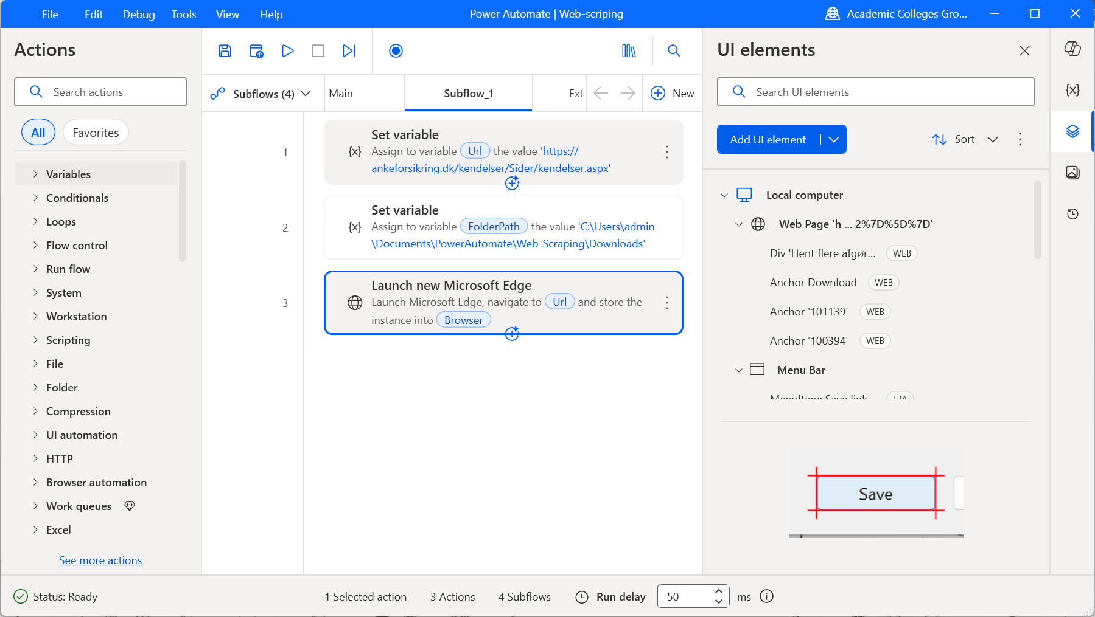
The system for entering initial values ​​was developed. To allow the user to flexibly manage the workflow, they need to set the required startup parameters. For this purpose, a source Excel file was created, allowing the user to specify various options and select the desired configuration during startup. This approach increases the system's flexibility and customizability.
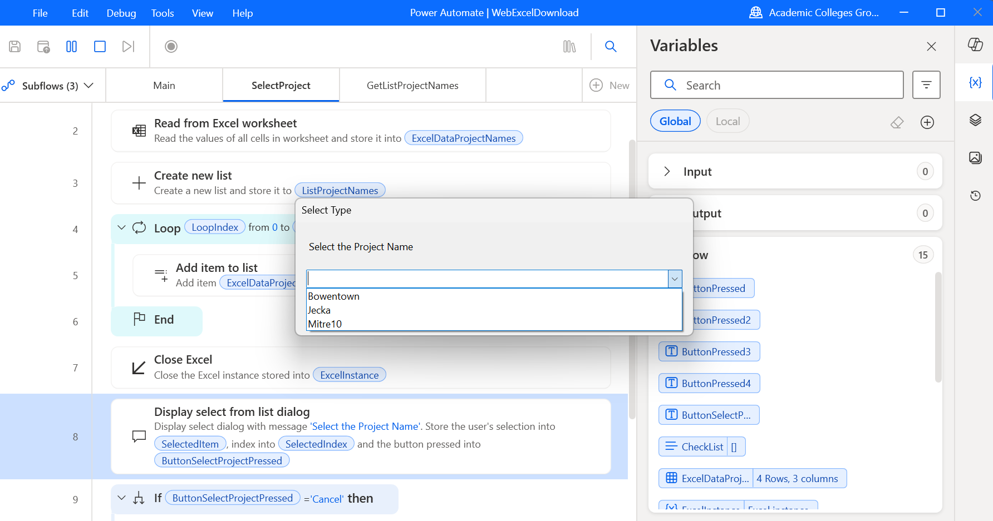

Problems Encountered
During the research and development of IT tools, I encountered various problems. One of them is the heterogeneity of incoming information. The data that needs to be processed comes from various sources and has different formats. To achieve this, the process needs to be trained to handle as many basic scenarios as possible and to anticipate what the process will do if it encounters an unexpected situation.
The Copilot tool is a very convenient AI assistant. It integrates well with Power Automate, but it can't yet construct a process described to it in human language. Instead, it selects recommended actions that can then be integrated into the process chain. This reduces the effectiveness of this AI assistant and requires a specialist with more in-depth knowledge in this area. However, the development prospects for this AI tool are clear, and in the future, it is expected to take over this function, allowing the user to focus on the logic of the process itself.
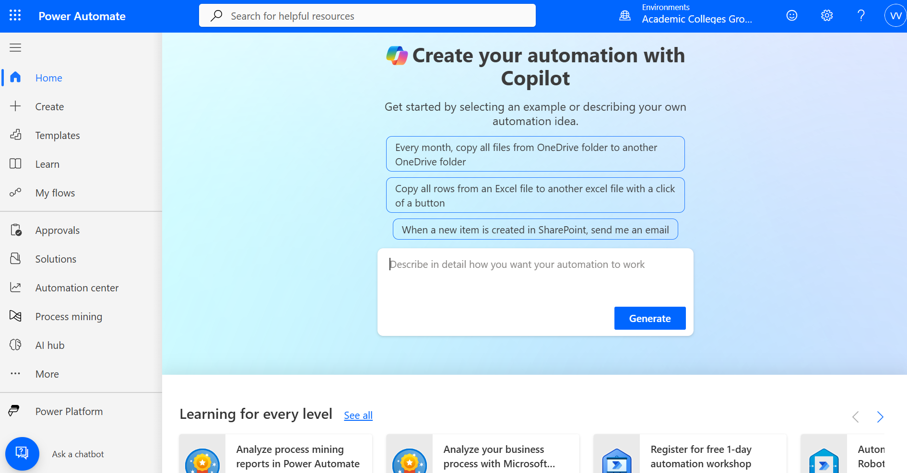
Another problem is that Copilot offers features that are unavailable in the current version or only for the premium pocket, and often the features' names don't match. You have to conduct additional research and find workarounds yourself.
Another observation was that AI recommendations do not always lead to the desired results and require testing. They could work perfectly in some situations and be completely useless in others. Therefore, these tools require adaptation before they can be widely used. This indicates that, despite the rapid pace of development and progress in AI, these tools are auxiliary in low-code programming, but they are very helpful.

How Problems were Dealt With
Sometimes I had problems with automatic detection of UI elements. Elements like the context menu in the Edge browser were difficult for PowerPoint Automate to detect. In this situation, it was necessary to write them manually or use the Wizard, which could look at a separate process and then take the necessary components from it and transfer them to your process.
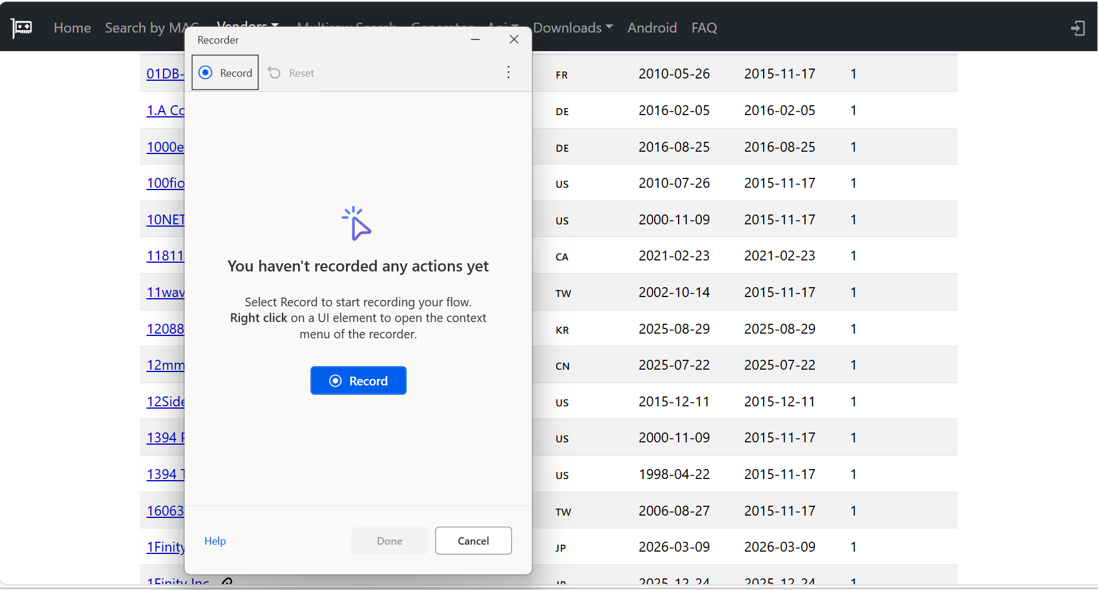
This tool is very helpful for tracking individual chains in complex situations and for workarounds.

Plan for Next Reporting Period
In the next stage of the project, I plan to focus on document processing and information retrieval functions using artificial intelligence tools such as AI Builder, Copilot and Open AI.
It is planned to study the best practices of using AI tools for optical text recognition, formation, organization and storage of data, as well as subsequent analysis and construction of forecasts.
Specifically, Microsoft AI Builder will be evaluated as a tool for extracting unstructured information from documents using optical character recognition (OCR) and organizing the information into a structured format. The obtained data will be combined in Excel and Notion to ultimately reduce manual labor and routine tasks and allow the manager to focus on other tasks.
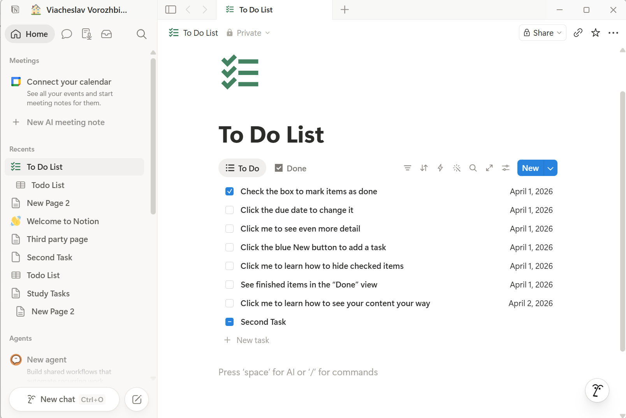
The Notion platform will also be integrated, as it is a popular and flexible information management platform well suited for small businesses. It is intended to be used to store project documentation, quotes, information on clients, suppliers, and contractors, and task lists. It is also planned to provide dashboards, project progress, and workflow status tracking. The possibility of integrating Notion with Power Automate will be explored to ensure automatic information updates, status changes, and forecasts.
It is also planned to evaluate the accuracy of OCR, the quality of data extraction, and the practical applicability of popular AI tools and MS AI Builder for the automation of a construction company.

References
AI-powered project scheduling systems: Enhancing construction timelines with real-time resource allocation and delay prediction analytics, Sept. 2025, doi: 10.5281/zenodo.17212648.
Wang, C., “The Role of Artificial Intelligence in Construction Management: A Case Study of Smart Worksite Systems,” Journal of Artificial Intelligence Practice, vol. 6, no. 8, Jan. 2023, doi: 10.23977/jaip.2023.060813.
S, A. K. G., Singh, R., Gehlot, A., Iqbal, M. I., and Akram, S. V., “A Comprehensive Approach to Real-time Site Monitoring and Risk Assessment in Construction Settings using Internet of Things and Artificial Intelligence,” SSRG International Journal of Electrical and Electronics Engineering, Sept. 2023, doi: 10.14445/23488379/ijeee-v10i8p111.
Lin, Z., Jiang, D., and Liu, J., “AI-Enabled Digital Transformation in the Construction Industry: A Comprehensive Framework for Smart Construction Management,” Sept. 2025, doi: 10.1145/3773365.3773568.
Obiuto, N. C., Adebayo, R. A., Olajiga, O. K., and Festus-Ikhuoria, I. C., “Integrating Artificial Intelligence in Construction Management: Improving Project Efficiency and Cost-effectiveness,” Deleted Journal, vol. 4, no. 2, pp. 639–647, Mar. 2024, doi: 10.62225/2583049x.2024.4.2.2550.
Parekh, R. and Mitchell, O. S., “Incorporating AI into construction management: Enhancing efficiency and cost savings,” International Journal of Science and Research Archive, vol. 13, no. 1, pp. 1049–1058, Sept. 2024, doi: 10.30574/ijsra.2024.13.1.1776.
Mohammed, A. F. and Mohammed, A. R., “AI-augmented safety management in construction,” International Journal of Computer Science and Information Technology, vol. 17, no. 5, pp. 107-124, Oct. 2025, doi: 10.5121/ijcsit.2025.17507.
Ojha, A. K., “AI Application in Project Management in Construction Industry,” Nov. 2025, doi: 10.5281/zenodo.18172124.
Sam M., Raut, A. S., Raut, A. S., -, J. Y., and -, A. L., “Role of Artificial Intelligence in Construction Project Management,” International Journal for Multidisciplinary Research, vol. 6, no. 6, Nov. 2024, doi: 10.36948/ijfmr.2024.v06i06.32064.

